# SOFTWARE INSTALLATIONS

|  |  |
| --- | --- |
| DATE | 16-NOVEMBER 2022 |
| TEAM ID | PNT2022TMID04163 |
| TEAM MEMBER | SHANTHOSHKUMAR G |
| PROJECT NAME | STATISTICAL MACHINE LEARNING APPROACHES TO LIVER DISEASE PREDICTION |

**Software Installations**

In order to develop this project we need to install following software/packages

# Anaconda Navigator:

Anaconda Navigator is a free and open-source distribution of the Python and R programming languages for data science and machine learning related applications. It can be installed on Windows, Linux, and macOS.Conda is an open-source, cross- platform, package management system. Anaconda comes with so very nice tools like JupyterLab, Jupyter Notebook, QtConsole, Spyder, Glueviz, Orange, Rstudio, Visual Studio Code. For this project, we will be using Jupyter notebook and Spyder.

**Installing on Windows:**

1. Download the Anaconda installer.
2. Go to your Downloads folder and double-click the installer to launch. To

prevent permission errors, do not launch the installer from the Favorites folder.

1. Click **Next**.
2. Read the licensing terms and click **I Agree**.
3. It is recommended that you install for **Just Me**, which will install Anaconda

Distribution to just the current user account. Only select an install for **All Users** if you need to install for all users’ accounts on the computer (which

Requires Windows Administrator privileges).

1. Click **Next**.
2. Select a destination folder to install Anaconda and click **Next**. Install Anaconda to a directory path that does not contain spaces or unicode characters. For more information on destination folders, see the FAQ.

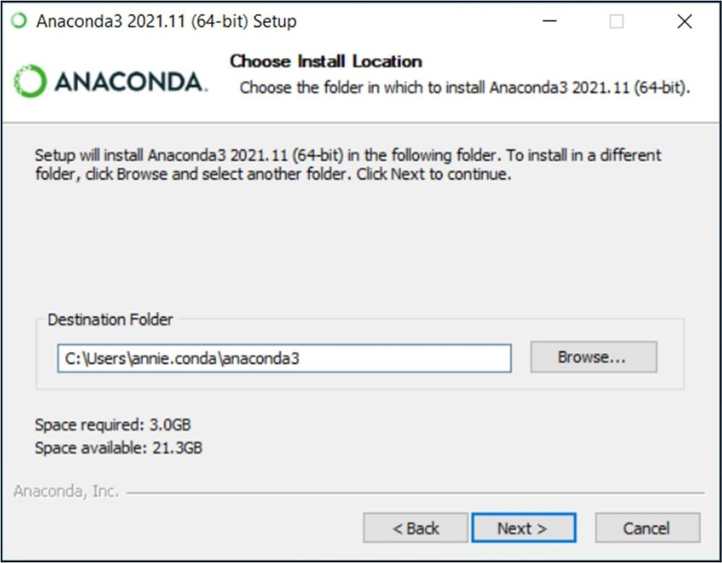

1. Choose whether to add Anaconda to your PATH environment variable or register Anaconda as your default Python. We **don’t recommend** adding Anaconda to your PATH environment variable, since this can interfere with other software. Unless you plan on installing and running multiple versions of Anaconda or multiple versions of Python, accept the default and leave this box checked. Instead, use Anaconda software by opening Anaconda Navigator or the Anaconda Prompt from the Start Menu.

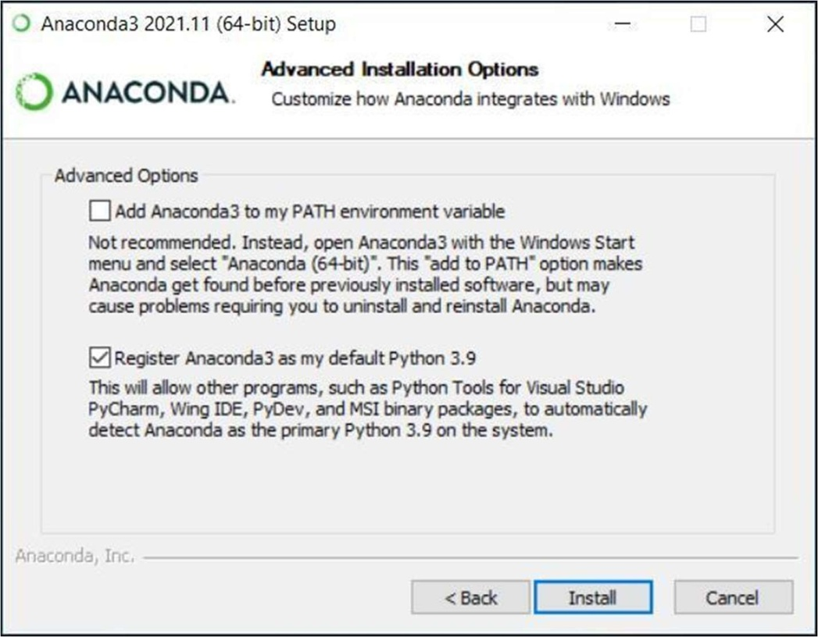

1. Click **Install**. If you want to watch the packages Anaconda is installing, click Show Details.
2. Click **Next**.
3. Optional: To install Data spell for Anaconda, click https://[www.anaconda.com/dataspell.](http://www.anaconda.com/dataspell) Or to continue without Dataspell, then click **Next**.

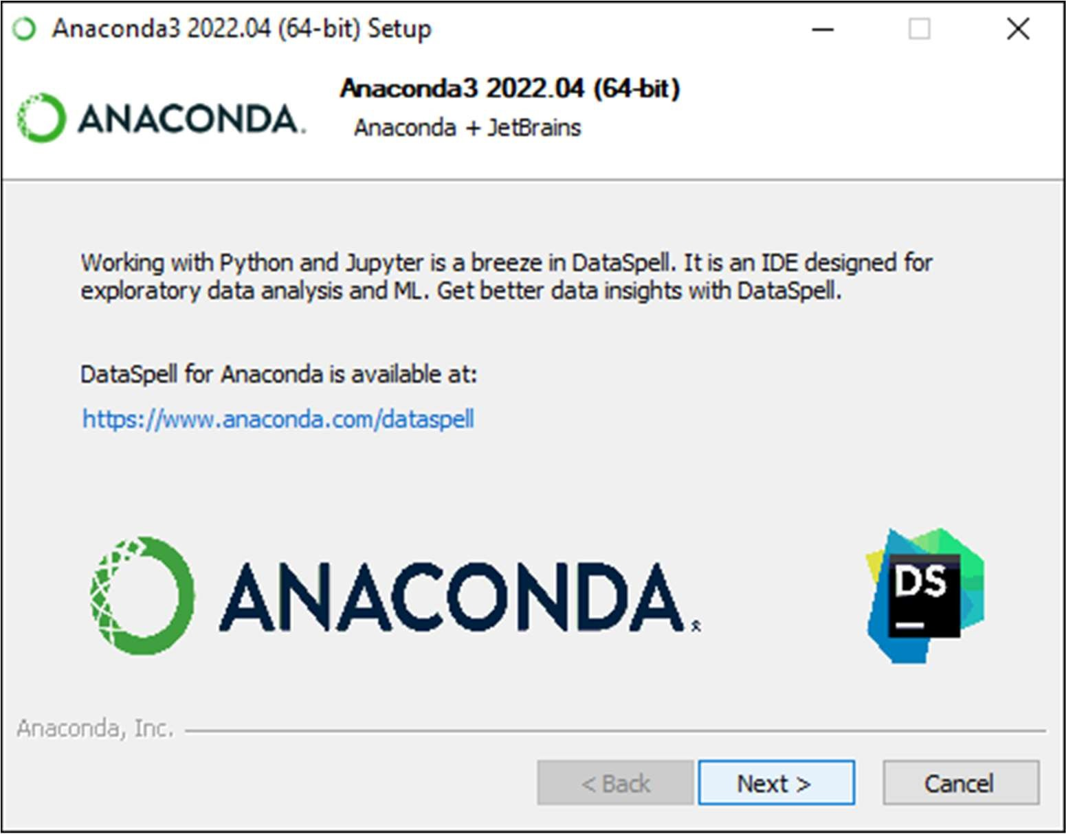

1. After a successful installation you will see the “Thanks for installing Anaconda” dialog box:
2. If you wish to read more about Anaconda.org and how to get started with Anaconda, check the boxes “Anaconda Distribution Tutorial” and “Learn more about Anaconda”. Click the **Finish** button.

